**Feedback Form**

Thank you for agreeing to take part in the testing of the new Oaxaca Restaurant website.

The goal of this project is to create an online order system, and subsequent staff portals, whilst still keeping the friendly and colourful values we hold.

Name:

Age: *(optional)*

Current Employment: *(optional)*

Have you worked in hospitality before:

**No**

**Yes**

Date:

Please turn your attention to the website and navigate through the pages, noting your feedback as you do.

**Home:**

How would you rate the design of the page?

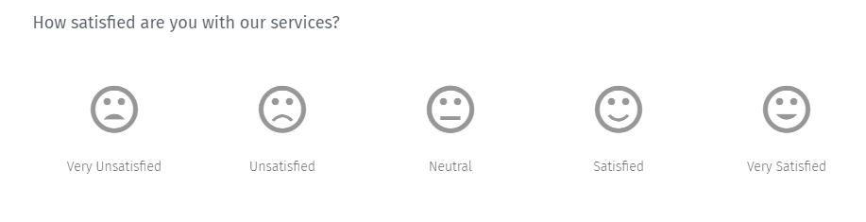

How responsive was the page? (e.g. images loading)



Did the page explain the online ordering process well?



How would you rate the overall page?



Please note what you like about the page

Could the page be improved in any way?

**About Us:**

How would you rate the design of the page?



How responsive was the page? (e.g. images loading)



Did the page explain the restaruant and it’s owners well?



How would you rate the overall page?



Please note what you like about the page

Could the page be improved in any way?

**Menus:**

How would you rate the design of the page?



How responsive was the page? (e.g. images loading)



How informative were the menu pages?



How would you rate the overall page?



Please note what you like about the page

Could the page be improved in any way?

**Order:**

How would you rate the design of the page?



How responsive was the page? (e.g. images loading)



How easy was it to order?



How would you rate the overall page?



Please note what you like about the page

Could the page be improved in any way?

**Log In/Sign Up:**

How would you rate the design of these pages?



How responsive were the pages? (e.g. images loading)



How easy was it to log in?



How easy was it to sign up?



Was the error handling correct and informative?



How would you rate the overall pages?



Please note what you like about the pages

Could the pages be improved in any way?

**Waiters Hub:**

How would you rate the design of the page?



How responsive was the page? (e.g. images loading)



How easy was it to view and modify customer orders?



How would you rate the overall page?



Please note what you like about the page

Could the page be improved in any way?

**Kitchen Staff Hub:**

How would you rate the design of the page?



How responsive was the page? (e.g. images loading)



How easy was it to view and set orders to delivered?



How would you rate the overall page?



Please note what you like about the page

Could the page be improved in any way?

**Entire Website:**

How would you rate the design of the website?



Was the website easy to navigate through?



How easy was it to learn how to and place orders?



How easy was it to progress through the mock customer’s order?



How would you rate the overall website?



Please note what you liked about the webiste

Could the website be improved in any way?

Thank you for taking part in the testing of our website.

Your responses will be extremely valuable in the further development of the product.

Please contact us at [abigail.hunter-blanco.2022@live.rhul.ac.uk](mailto:abigail.hunter-blanco.2022@live.rhul.ac.uk) if you have any questions.